Software Requirements Specification (SRS)
Vexa – AI-Powered Knowledge Hub

Version: 1.0
Date: August 21, 2025
Status: Draft
Prepared By: Lead Architect/Product Manager Arpreet Mahala
Prepared For: Vexa Development Team, QA Team, and Stakeholders

- Introduction
1.1 Purpose
This document provides a detailed description of the functional and non-functional requirements for the Vexa – AI-Powered Knowledge Hub software system. It is intended to serve as a complete specification for the development team, a foundation for test planning and execution by the QA team, and a reference for project managers and stakeholders to ensure a common understanding of the project's scope and capabilities.

1.2 Scope
Vexa is a cross-platform (Web, iOS, Android) cloud-based application designed to serve as a centralized, intelligent repository for personal and organizational knowledge. The core value proposition is the use of Artificial Intelligence to process, summarize, and retrieve information based on meaning and context, not just keywords.
The Minimum Viable Product (MVP) will include:
User account creation and management.
Creation, editing, and organization of rich-text notes.
Secure upload, storage, and management of documents (PDF, DOCX, TXT).
AI-powered summarization of notes and documents.
Semantic search across the user's entire knowledge base.
A quick-capture widget for rapid idea entry.
Real-time synchronization of all data across all user devices.
Out of Scope for MVP: Team workspaces, advanced access controls, real-time collaborative editing, third-party integrations (e.g., Google Drive, Slack), native desktop clients, and advanced AI features like concept mapping or trend analysis.

1.3 Definitions, Acronyms, and Abbreviations

Term | Definition
AI | Artificial Intelligence.
LLM | Large Language Model (e.g., GPT-4, Claude). The technology powering summarization and semantic search.
NLP | Natural Language Processing.
JWT | JSON Web Token. A method for secure authentication.
REST API | Representational State Transfer Application Programming Interface.
CRUD | Create, Read, Update, Delete. Basic data operations.
MVP | Minimum Viable Product.
UI/UX | User Interface / User Experience.

1.4 References
IEEE Std 830-1998 - IEEE Recommended Practice for Software Requirements Specifications.
Vexa Business Requirements Document (BRD), Version 1.0.
GDPR Regulation (EU) 2016/679.
1.5 Overview
The remainder of this document is structured as follows: Section 2 provides an overall product perspective and user classes. Section 3 contains the detailed, specific requirements, which are the core of this document. Section 4 covers non-functional requirements, and Section 5 includes appendices for supplementary information.

- Overall Description
2.1 Product Perspective
Vexa is a standalone, self-contained system. Its primary interaction with external systems will be through:

Third-Party AI/ML APIs: For advanced summarization and semantic indexing capabilities.
Cloud Storage Providers (AWS S3/Azure Blob Storage): For secure, scalable file storage.
Authentication Providers (Optional - Future): Such as Google OAuth or Microsoft Entra ID.

High-Level System Context Diagram:

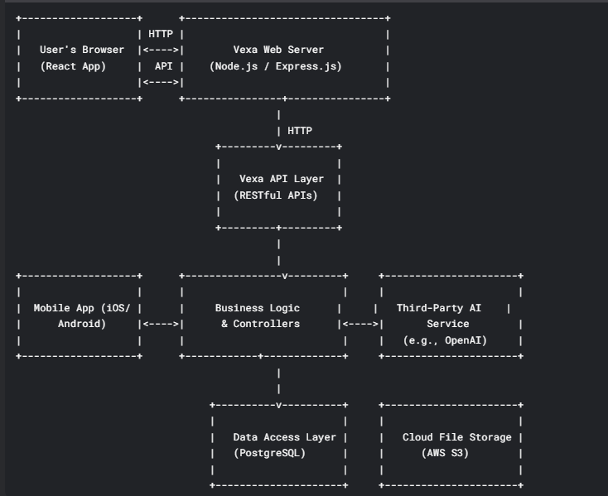

2.2 User Classes and Characteristics

User Class | Characteristics | Key Requirements
End User (Individual) | Students, professionals. Single account. Tech-savvy but not necessarily technical. | Intuitive UI, fast performance, reliable sync, powerful search.
Administrator (Future) | IT/System admin for an organization. Manages users, groups, and settings. | User management dashboards, access controls, usage analytics.

2.3 Operating Environment
Frontend
Web: Next.js + React.js (SPA with SSR/SSG), optimized for latest Chrome, Firefox, Safari, and Edge.
Styling: Tailwind CSS for responsive and consistent UI.
Hosting: Deployed on Vercel (serverless, edge-optimized).
Mobile
Responsive PWA (Progressive Web App) powered by Next.js.
Compatible with iOS (14+) and Android (10, API Level 29+) browsers.
Backend
Runtime & Framework: Spring Boot (Java, latest LTS).
APIs: REST API + WebSocket for CRUD operations and real-time collaboration.
Deployment: Containerized using Docker, deployable on AWS Free Tier (EC2/ECS/EKS).
Database & Storage
Primary DB: PostgreSQL 14+ (AWS RDS Free Tier).
Cache: Redis (for session caching & performance optimization).
File Storage: AWS S3 (for documents, media, and user uploads).
AI & Real-Time Processing
AI: Google Gemini API for summarization, quiz generation, and semantic search.
Streaming: Apache Kafka for real-time updates, collaboration, and notifications.

Authentication & Security
Auth: Spring Boot Security + JWT (role-based access & secure authentication).
Scanning: OWASP ZAP for vulnerability assessment.
CI/CD & Testing
CI/CD: GitHub Actions for automated builds, testing, and deployments.
Testing: JUnit + Mockito (backend), Jest + React Testing Library (frontend).
Documentation & Analytics
API Docs: Swagger (OpenAPI) for auto-generated API documentation.
API Testing: Postman collections for validation & sharing.
Analytics: Google Analytics to monitor user behavior and engagement.

2.4 Design and Implementation Constraints
Data Privacy: The system must be designed to comply with GDPR. All user data, including processed text for AI, must be treated under strict privacy protocols.

Personal data must not be used to train third-party AI models without explicit, opt-in user consent.
Cost: The architecture must be cost-optimized. Strategies for caching and limiting calls to paid third-party AI APIs must be implemented (e.g., caching summaries).
Technology: The backend must be implemented in JavaScript/TypeScript (Node.js) to leverage existing team expertise.
2.5 Assumptions and Dependencies
Dependencies:
Availability and performance of third-party AI services (e.g., OpenAI API).
Stability and scalability of chosen cloud infrastructure (AWS/Azure).
Assumptions:
Users will have intermittent internet connectivity; the mobile app must handle offline scenarios gracefully.
The average document size for summarization will be under 20 pages or 100KB of text for the MVP phase.
3. System Features & Requirements
3.1 User Authentication and Management
3.1.1. User Registration (FR-01)

Description: A new user can create an account.
Inputs: Email address, password (with strength validation), full name.
Processing: System hashes password, creates user record, sends email verification link.
Outputs: New user account in a "pending verification" state.
3.1.2. User Login (FR-02)
Description: A registered user can log in.
Inputs: Email, password.
Processing: System validates credentials, generates a JWT.
Outputs: JWT returned to client for authenticating subsequent requests.
3.2 Smart Note-Taking (FR-03)
Description: User can create, read, update, and delete rich-text notes.
Detailed Requirements:
FR-03.1: Provide a WYSIWYG editor supporting bold, italics, underline, bulleted/numbered lists, and headings (H1, H2, H3).
FR-03.2: Notes are auto-saved every 30 seconds or upon manual trigger.
FR-03.3: Notes have a title and a body.
FR-03.4: User can permanently delete a note, with a confirmation dialog.
3.3 Document Management (FR-04)
Description: User can upload, view, and manage documents.
Detailed Requirements:
FR-04.1: User can upload files via drag-and-drop or a file browser dialog.
FR-04.2: Supported formats: .pdf, .docx, .txt.
FR-04.3: Maximum file size: 25 MB.
FR-04.4: Uploaded files are stored in encrypted cloud storage (AWS S3). The database stores a secure reference to the file.
FR-04.5: User can view a list of all their documents, sorted by date/name.
FR-04.6: User can delete a document, which removes it from storage and the database.
3.4 AI-Powered Summarization (FR-05)
Description: User can generate a summary of a note or document.
Detailed Requirements:
FR-05.1: A "Summarize" button must be present in the UI for notes and document viewer.
FR-05.2: The system extracts text from the source (note content or document).
FR-05.3: The extracted text is sent to the configured third-party AI summarization API.
FR-05.4: The system caches the generated summary using the source content's hash as a key to avoid redundant, costly API calls.
FR-05.5: The summary is displayed in a clear, readable format within the UI.
Performance Requirement: 90% of summarization requests shall complete within 5 seconds.
3.5 Semantic Search (FR-06)
Description: User can search all their content using natural language queries.
Detailed Requirements:
FR-06.1: A single, prominent search bar is available on all main views.
FR-06.2: As the user types, relevant results are displayed in a dropdown (type-ahead functionality).
FR-06.3: The search query and all note/document text are vectorized using an embedding model.
FR-06.4: Search results are ranked by cosine similarity between the query vector and content vectors.
FR-06.5: Results are displayed with the title, a relevant snippet, and an indication of the item type (Note/Doc).
Performance Requirement: 95% of search queries shall return results in under 2 seconds.
3.6 Quick Capture Widget (FR-07)
Description: User can quickly create a note without opening the full application.
Detailed Requirements:
FR-07.1: On mobile, this is a persistent floating button that opens a minimal text input screen.
FR-07.2: On web, this is a browser extension popup or a minimized UI element.
FR-07.3: The captured text is immediately saved to the user's account and synced.
3.7 Data Synchronization (FR-08)
Description: All user data is synchronized across all their devices in near real-time.
Detailed Requirements:
FR-08.1: Changes made on one device (create, update, delete) are propagated to the server.
FR-08.2: Other devices poll for changes or maintain a WebSocket connection to receive updates promptly.
FR-08.3: The mobile app must support offline mode. Changes made offline are queued and synced once connectivity is restored. Conflict resolution will be "last write wins" based on a timestamp for the MVP.

4. Non-Functional Requirements
4.1 Performance Requirements
P-01: Application Home Screen Load Time: 95% of requests shall load the main dashboard in under 3 seconds on a 4G connection.
P-02: API Response Time: 99% of all API calls shall respond in under 500ms.
P-03: Search Response Time: As defined in FR-06.5.
P-04: Summarization Time: As defined in FR-05.5.
4.2 Security Requirements
S-01: All data in transit must be encrypted using TLS 1.2 or higher.
S-02: Passwords must be hashed using a strong, adaptive algorithm (e.g., bcrypt).
S-03: Authentication must be stateless using JWTs. Tokens must have a reasonable expiration time (e.g., 24 hours).
S-04: Users must only be able to access their own notes and documents. All API endpoints must include authorization checks.
S-05: Files at rest in cloud storage must be encrypted using AES-256.
4.3 Software Quality Attributes
Availability: The system shall achieve 99.9% uptime.
Reliability: The system shall have a Mean Time Between Failures (MTBF) of no less than 720 hours.
Maintainability: The codebase shall have a test coverage of >80% for backend services. All code must pass linting checks.
Usability: The system shall be designed to be intuitive enough that a new user can create a note and upload a document without reading documentation. Target an System Usability Scale (SUS) score of >80.
Scalability: The system shall be designed to handle a 50% increase in user load without degradation of performance, given proportional scaling of resources.
5. Other Requirements
5.1 Database Schema (Preliminary)
users table: id, email, password_hash, full_name, created_at
notes table: id, user_id (FK), title, content, created_at, updated_at
documents table: id, user_id (FK), original_filename, storage_path, mime_type, uploaded_at
tags table: id, user_id (FK), name
note_tags table: note_id (FK), tag_id (FK) // Junction table for many-to-many
document_tags table: document_id (FK), tag_id (FK) // Junction table for many-to-many
summaries table: id, source_id, source_type ('note' or 'document'), content_hash, summary_text, created_at // For caching
Appendix A: Acceptance Criteria (Examples)
Given a user is on the login page, when they enter valid credentials, then they are redirected to the dashboard.
Given a user is viewing a PDF, when they click "Summarize", then a summary is displayed within 5 seconds, and the summary accurately reflects the document's key points.
Given a user is offline on their mobile device, when they create a new note, then the note is visible locally, and when connectivity is restored, the note appears on their web client.

